**Readme document for HBT OneHR system**

This readme covers usage of the HBT OneHR tool and is intended to help you in navigation in the website and a understanding of the functions available in OneHR at this time.

To access OneHR website - [click here](https://ess.highbartech.com/hrms/login.aspx)

Link to website - https://ess.highbartech.com/hrms/login.aspx

**Please note – We are approaching OneHR launch in a phase-wise manner. Not all features available to view are active at this time.**

In this phase of the system, we have the following features available.

|  |  |  |
| --- | --- | --- |
| **Topic** | **Active function at this time** | **Function detail** |
| Leave | Viewing your balance | View |
| Applying for leave | Apply, cancel |
| Approving leave for team members | Approve, cancel |
| My corner | Change password | Change password feature |
| Link to HGS website for payslips | Link to external website |
| Link to change PF and Mediclaim nominations | Apply only |
| Claims | Reimbursement vouchers | Reimbursement claims for all bands |
| Fuel | For select bands, as per eligibility |
| Mobile | For select bands, as per eligibility |
| Contacts | Directory of employees | View |
| Policies | HR policies | View policies |

INDEX - Click on the topic to quickly navigate to it

1. Logging in
2. Navigating the website
   1. Leave
   2. Vouchers
   3. My corner
   4. Contacts
   5. Policies
3. [How to ->](How_to#_)
   1. Apply for leave
   2. Approve leave
   3. Apply reimbursement vouchers and other claims
   4. Approve claims.
4. Workflows configuration ( for reference on approval hierarchies)
   1. Workflows for HO employees
   2. Workflows for Site based employees

# How to use the website – Logging in

**Logging in**

The below link takes us to the OneHR system.

<https://ess.highbartech.com/hrms/login.aspx>

**Username & password** - Your username and password have been sent to you via separate email from [tushar.prabhakar@highbartech.com](mailto:tushar.prabhakar@highbartech.com)

There is no separate logout option on the website. You are logged out automatically after you close the browser window.

# Navigating the website

**Landing page**

The landing page snapshot is given below.

Many features are listed, but not all are active, as they are being developed.

The active features are listed in the table at the starting of this readme document.

They are also highlighted in red in the snapshot below.

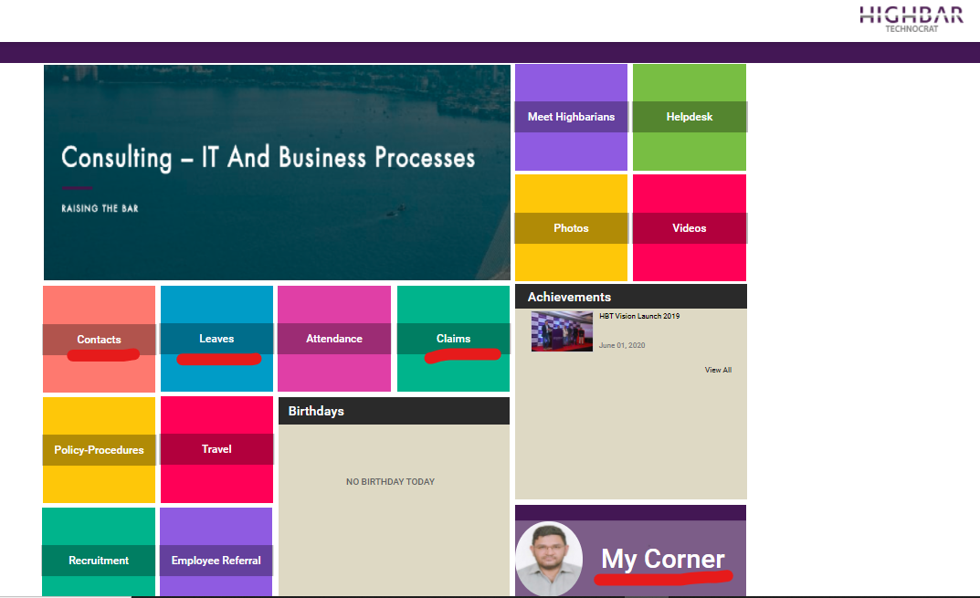

*Fig 1. Landing page/ homepage view*

## Topic – Leave

- To view your leave balance and to apply/ approve leave, click on “leaves”. On the homepage.

– The landing page looks as below. Your leave balance is shown in the table displayed.

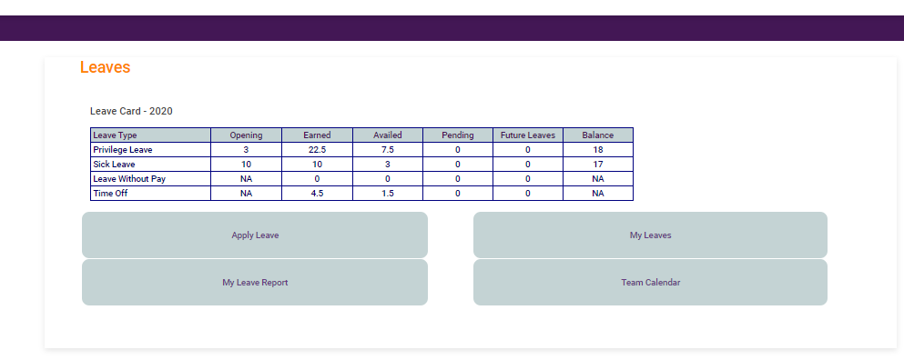

*Fig 2.0 Employees default view of “Leaves” page*

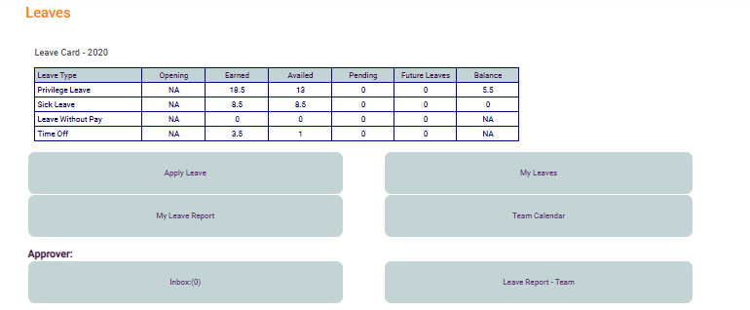

*Fig 2.1 Managers view of the leave page*

**Details of features available on leave page –**

Apply leave – Apply here for leave (both past dated and future dated).

My leaves – captures the dates of your availed leave in this year.

My leave report - Generates a report of your leave activity.

Team calendar – manager feature, this enables a view of your team’s leave activity as a month view. If you are not a team manager, it will show you only your leave dates, and not your team member details.

For leave approvers –

Reporting managers, project managers, program managers and HOD’s have this feature enabled.

Inbox - The inbox is where your team leave applications are available for approvals etc. You should use this feature to access the leave application and take further action.

Leave report- Team –

Reporting managers, project managers, program managers and HOD’s have this feature enabled.

This gives you a detailed report of the employee leave applications across PL, SL and TO.

**Leave application and approval is covered in detail in further parts of this document, under how to section.**

## Topic – Vouchers

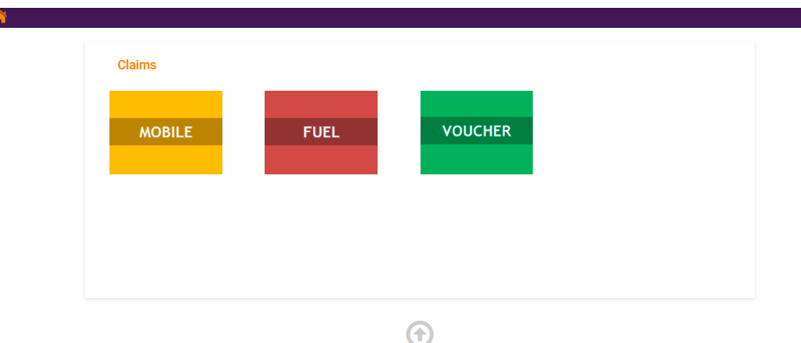

*Fig 3.0 Claims page view*

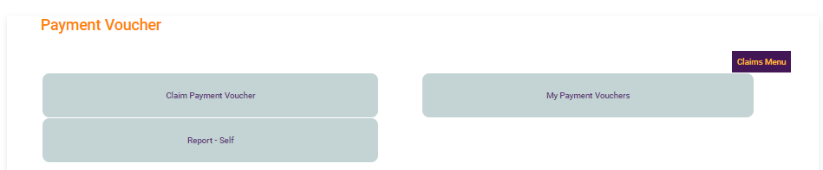

*Fig 3.1 employees voucher view – employee*

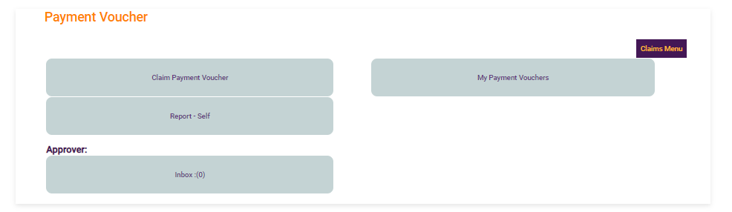

*Fig 3.2 Payment voucher view – Approver/Manager*

The claims page is where you can apply for all types of reimbursements (Ref Fig 3.0)

The mobile and fuel reimbursements are configured as per HBT bands. If you are not eligible for the same, the system will restrict you from applying.

Vouchers are accessible for all members. You can click on “voucher” to apply for all reimbursements, as applicable. Approval workflow is as per the hierarchy stages at head office and at project sites, respectively.

## Topic - My corner

You can change your user password and send nomination changes for your PF and Mediclaim as a notification to the HR team.

## Topic - Contacts

The details of company employees can befound here. The system contains employees registered so far in the current phase of OneHR . It does not cover all employees at this time.

**For any addition, deletion or change in the records, reach out to HR@highbartech.com**

## Topic – Policies

The current company policies can be found here.

# “How to” Section

## **How to** -> Apply for leave

While Applying for leave, start by clicking on “apply leave” (ref fig 2.0).

Leave rules are configured as per existing HBT policy on leave.

**Step 1** – click on apply leave.

Leave types are configured with hierarchy levels as per your reporting structure. The names of the approvers appear at the bottom of the page for easy understanding of application status.

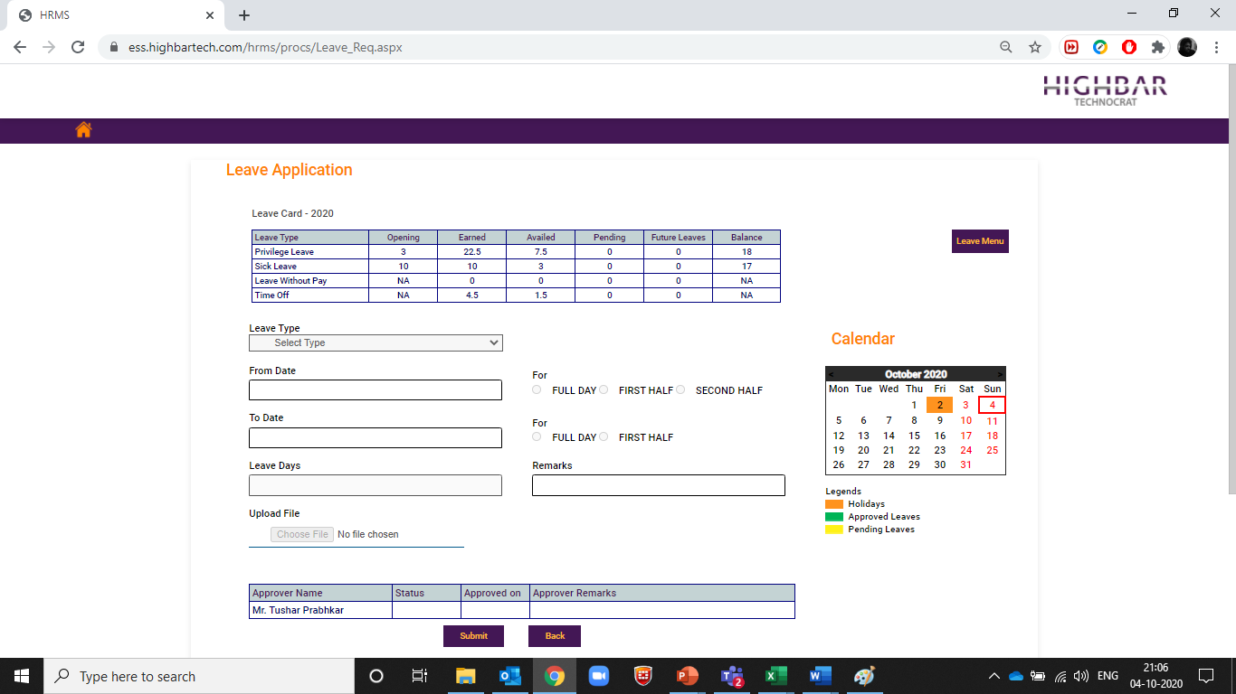

*Fig 4. – Leave application page*

**Step 2** – Click on the type of leave you desire to avail from the dropdown “leave type”. Select the from date, to date and the duration (half day etc.) as applicable. (Ref Fig 4)

For sick leave (SL), you may have to upload medical documents to substantiate the sick leave period. In case and wherever required as per HBT policy, you will be prompted for the same. You can upload the documents in upload file option

**Step 3** – Your leave approval hierarchy is shown in the table below. (Ref fig 4)

**Step 4** – Click on submit and your leave is applied. It goes for approval as per the table below, to the next level of approval. the approval stages and comments are also updated here. (Ref fig 4)

## **How to ->** approve leave

As a team manager, you will get an email trigger notification on your HBT email ID whenever someone in your team applies for leave.

Navigate to inbox on the leave page. (Ref fig 2.1.)

This is where you will find the leave application. Click on the pencil icon to take the approval ahead. You can approve or reject leave and enter comments.

The leave application them moves to next stage for approval, if applicable.

## **How to** -> Apply for Fuel, mobile, all other reimbursement

**Vouchers workflows are updated ! Refer vouchers readme file for detailed step by step guide !**

**Step 1**. Click on voucher type as applicable. (Ref fig 3)

**Step 2.** Click on type of voucher (ref fig 3.1). The site navigates to the payment voucher view. (Ref fig 3.1).

**Step 3.** Fill in the details as on screen. Select the type of expense, upload the bills softcopy and click on submit ( ref fig 3.4)

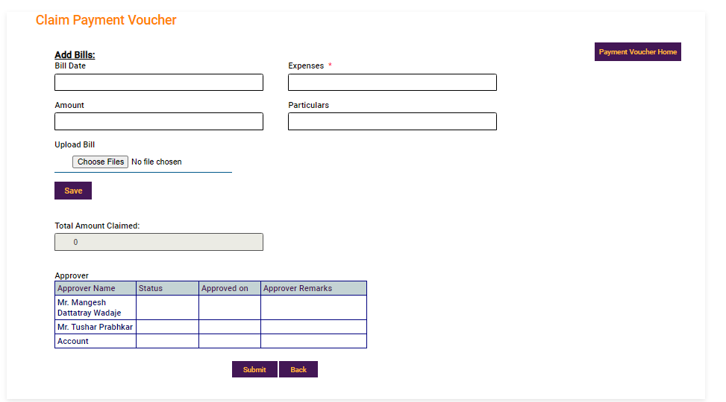

*Fig 3.4 -Claim voucher payment*

## **How to** -> Approve claims

This feature is available to team managers.

You will receive email notification once your team member applies for a reimbursement.

**Step 1.** Applications are visible in the inbox. Click on the inbox to view applications (ref fig. 3.2)

**Step 2**. Click on the pencil icon in the application to view and approve the same.

**NOTE -** If the claim is an exceptional one and needs approval of the CEO as per the policy of HBT, you can click and select the “is exception” button. This will add CEO to the approval workflow before it reaches accounts team.

**Step 3**. Click on approve/reject claim.

# Workflows

It is important to note that the system is configured to recognize if you are based out of a corporate function like sales & BD, marketing, HR, accounts, admin, innovation or if you are posted/deputed to a project.

Both have different approval workflows, which are illustrated below.

Claim approval hierarchy follows your reporting hierarchy.

## For corporate functions and employees based out of Head office

Workflow for PL, TO and SL <=5days

* Reporting Manager
* HOD

Workflow for ML and SL > 5days

* Reporting Manager
* HOD
* Admin HR

If you are based at a project site, you reporting hierarchy is configured as per your project details.

Mobile bills reimbursement workflow for Head office-based employees:

These can be claimed monthly once. Current month bill can be claimed in next month

* Exceptional payments are allowed. If tagged as “Exception” then CEO would be added in approval workflow.
* Workflow would be as follows;

1. COS-Admin - [tushar.prabhakar@highbartech.com](mailto:tushar.prabhakar@highbartech.com)
2. Reporting Manager
3. HOD
4. CEO (if exception)
5. Accounts

Payment voucher reimbursement workflow for Head office based employees:

* If tagged as “Exception” then CEO would be added in approval workflow. Workflow would be as follows;

1. Reporting Manager
2. HOD
3. CEO (if exception)
4. Accounts

Fuel bills reimbursement workflow for Head office based employees:

* Can be claimed monthly more than once. Workflow would be as follows;

1. COS-Admin
2. Reporting Manager
3. HOD
4. Accounts

* Current month bill can be claimed in next month. Eligible Users cannot claim bills more than yearly entitlement. Car-washing/parking charges would be paid once monthly. Monthly pass would be paid once monthly.

## For project sites (including projects physically operating out of head office)

Workflow for PL, TO and SL <=5days

* Project Manager
* Program Manager
* Delivery Head

Workflow for ML and SL > 5days

* Project Manager
* Program Manager
* Delivery Head
* Admin HR

Mobile bills reimbursement

If tagged as “Exception” then CEO would be added in approval workflow. Workflow would be as follows;

1. COS-Admin - [tushar.prabhakar@highbartech.com- correction](mailto:tushar.prabhakar@highbartech.com-%20%20correction)
2. Project Manager
3. Program Manager
4. Delivery Head
5. CEO (if exception)
6. Accounts

* Current month bill can be claimed in next month

Payment voucher reimbursement:

* If tagged as “Exception” then CEO would be added in approval workflow. Workflow would be as follows;

1. Project Manager
2. Program Manager
3. Delivery Head
4. CEO (if exception)
5. Accounts

Fuel bills reimbursement: (only if entitled for fuel bill reimbursement)

* Can be claimed monthly more than once. Workflow would be as follows.

1. COS-Admin - [tushar.prabhakar@highbartech.com](mailto:tushar.prabhakar@highbartech.com)
2. Project Manager
3. Program Manager
4. Delivery Head
5. Accounts

Current month bill can be claimed in next month. Eligible Users cannot claim bills more than yearly entitlement. Car-washing/parking charges would be paid once monthly. Monthly pass would be paid once monthly.